Standard Operating Procedure (SOP)
Transport Services at MAHE Bengaluru Campus

OBJECTIVE:
Bus facility to Faculty, students & staff from various parts of the Bangalore city to the MAHE BLR campus. The buses are safe and comfortable for transportation.
SCOPE:
The transport process ensures smooth functioning of buses on timely basis and ensures proper functioning of the transport system.
RESPONSIBILITY:
Transport facility is managed by office of the DDGS MAHE BLR Campus. Pick and drop facility is arranged as per university timings.
PREFERENCE:
- First Preference Will be given to the students.
- If there is any vacancy, then the facility will be extended to MAHE employees and later for outsourced employees.
PROCESS FOR BUS BOOKING:
- The faculty, staff & students will have to approach the Department of Transport.
- Details related to bus booking will be shared by Department of Transport.
- Bus routes will be shared by the Department of Transport.
- Payment link (only for students) will be shared by Department of Transport to the students for necessary payments based on the routing.
GUIDELINES:
- All the students, Faculty and staff should be in their boarding point before 10 minutes of their pickup point. Bus will not wait for any reason for any delay.
- All the faculty and staff should display their ID card daily before boarding the bus.
- The students, faculty & staff should not celebrate birthday parties & festivals in the bus.
- Never stop the bus anywhere except at the designated points. Bus Services are provided for the commutation between designated pickup point to university and back only. Do not deviate or stop the bus en route for any personal reasons.
- Students and staff should follow the instructions by Department of Transport.
- While on the bus, students must conduct themselves in a quiet and courteous manner, showing consideration for the comfort and safety of others.
- Scuffling, fighting, smoking, alcoholic beverages and using obscene language in the bus are strictly prohibited.
- The bus users must use the bus route number, which is allotted to them by the Department of Transport. They cannot change or use the bus by their own choice. To change the pickup and drop point, bus users must take permission from the Department of Transport through email communication with proper approvals from the office of DDGS.
- In case the vehicle stops at an unscheduled spot, please inform to the Department of Transport.
- Be vigilant and alert throughout the journey. Stay alert of the route. Take care of your personal belongings in the bus. Avoid expensive or noticeable jewellery. University is not responsible for your personal belongings.
- Whenever there is any traffic violation by the driver, inform to the Department of Transport about the same.
- If you observe any strange person sitting along with the driver and do not board the vehicle inform the same to Department of Transport.
- In case of vehicle breakdown during the journey, please report the same immediately to the Department of Transport.
- Please ensure you alight yourself only inside the campus while you are reporting to campus and board the bus only at the designated boarding point inside the campus premises.
- Do not encourage the driver to play loud music in the bus.
- Do not involve in unnecessary conversations.
- Do not instigate the driver for speeding the bus.
- Do not call bus driver for any unscheduled pickup and drop even in case of emergency.
- Do not tip the driver in any way and do not get involved with the drivers in any financial support.
- Do not drive the bus. All commercial vehicles are to be driven by a person who holds valid “Transport Badges” from the competent authorities.
- Do not engage with drivers in any verbal/physical altercations in case of any conflicts. Please report it to the Department of Transport.
- Do not make any verbal complaints about the driver while you are on travel. Please report to the Department of Transport about driver and vehicle maintenance etc.
- Do not alter the sequence of drop or pickup of the scheduled route.
- In case of change in vehicle or route, do not travel without authentication by the Department of Transport.
- Be alert to anything abnormal and be confident, do not panic.
- Ensure the driver keeps to well used roads and avoid deserted areas.
- Co-operate with Department of Transport by answering their tracking calls.
- In case of complaints against any commuters for indiscipline behaviour, the bus driver will report immediately to the Department of Transport and disciplinary actions will be taken against the defaulter by the university.
- University has the rights to change the pickup and drop points, timings, and routing list.
- All students who have paid the transportation fees will be issued with bus pass.
- Students are requested to collect the bus pass at the office of transport [Security Block, Gate No.1, - 1st floor].
- All the students should display their Bus pass daily before boarding the bus, this is mandatory. And students are required to follow the rules and regulations. “Help us to serve you better”.

Note: Students, Faculty/Staffs should ensure and utilise only one route bus for boarding and de boarding the bus.

Team Lead: Vinod. G Escalation Matrix
SL No | Name | Designation | Level | Contact No. | Mail id
1 | Srinivas | Transport Supervisor | L1 | 9036800409 | transport.maheblr@manipal.edu
2 | Madhu J | Transport Executive | L1 | 9036800409 | transport.maheblr@manipal.edu
3 | Vinod G | Admin (MAHE) | L2 | 9902787023 | vinod.g@manipal.edu
4 | Basawaraj Kuppasad | DDGS (MAHE) | L3 | - | basawaraj.sk@manipal.edu

Note:
- The transport fees is leviable per semester and payable in advance in one instalment.
- The transport fee once paid will not be refundable.
- Increase in fuel prices may necessitate a revision in the transport fees.
- Transport fees are based on the travel distance to the Campus:

Transport Fee: Students with valid enrolment number.
Step 1 : Log in to MU SLcM. https://slcm.manipal.edu/
Step 2: Select Application Tab on top.

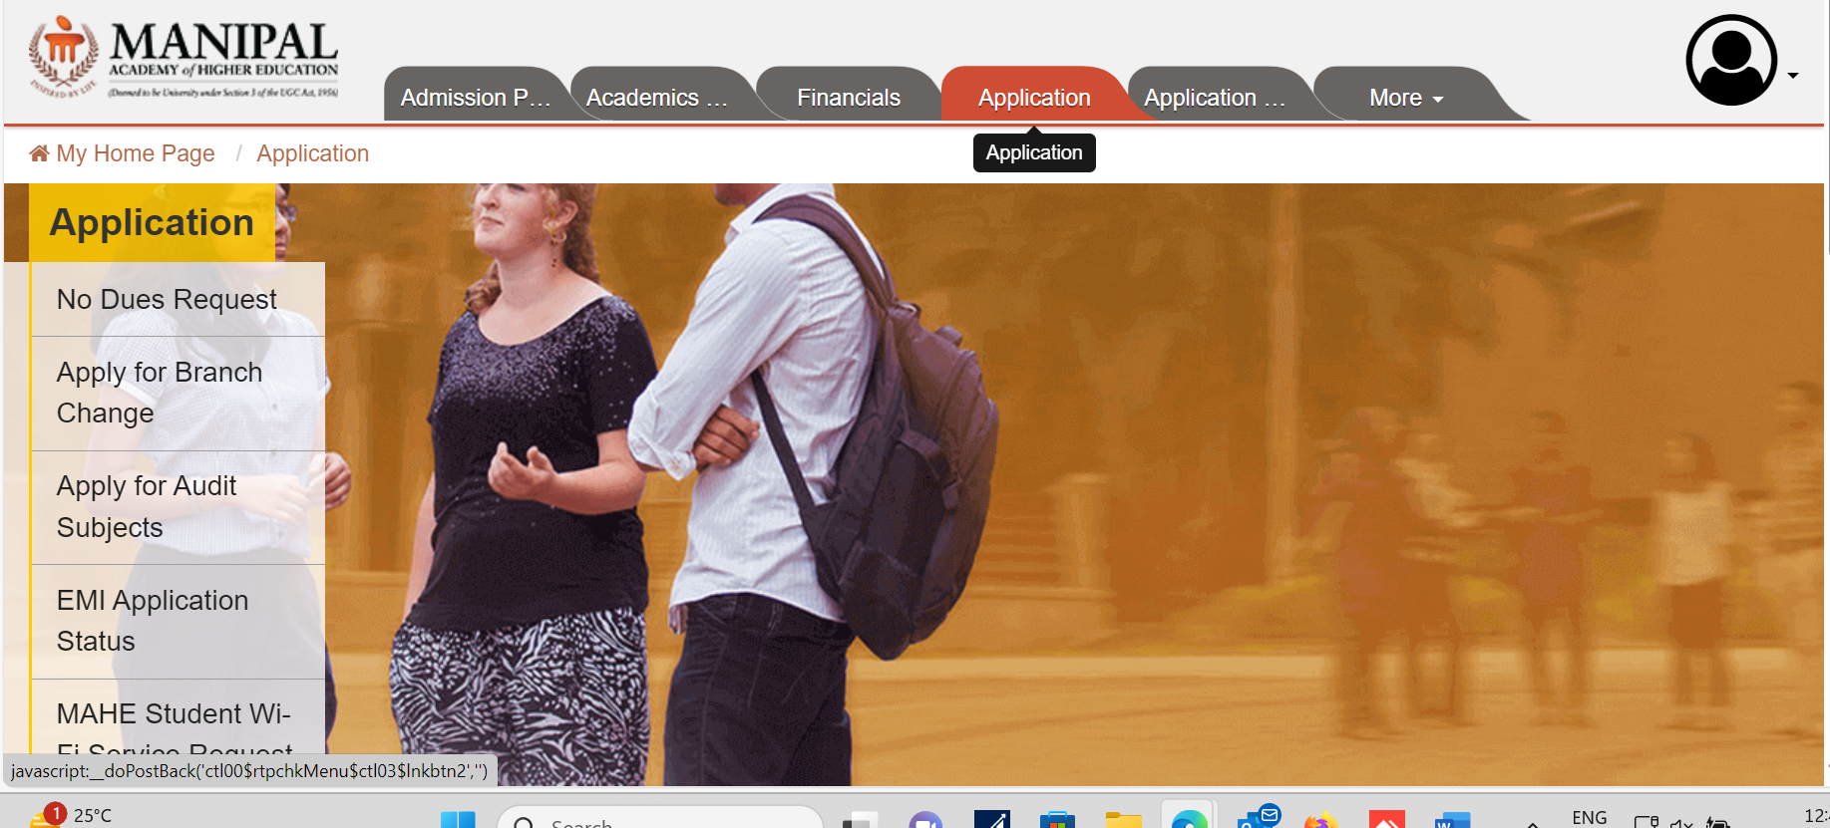

Step 3 : Select fee payment option.
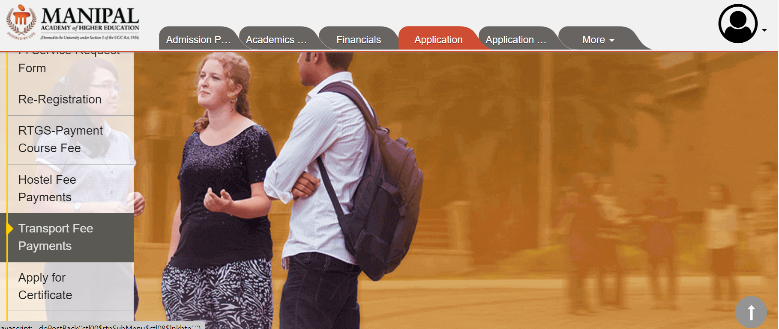

Step 4: Select route and boarding point.

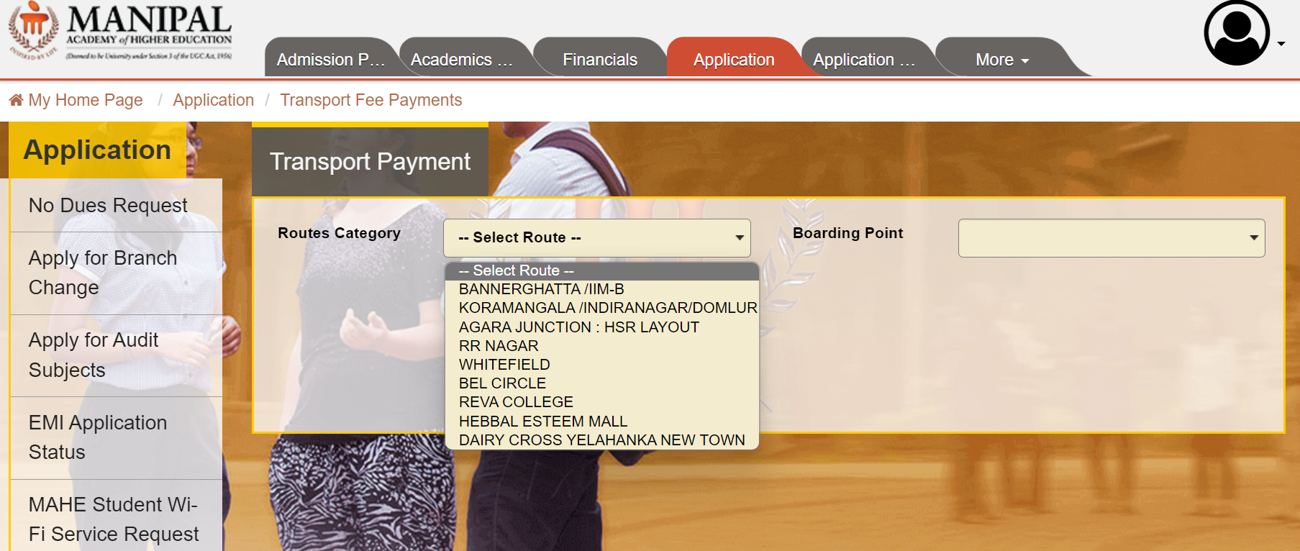

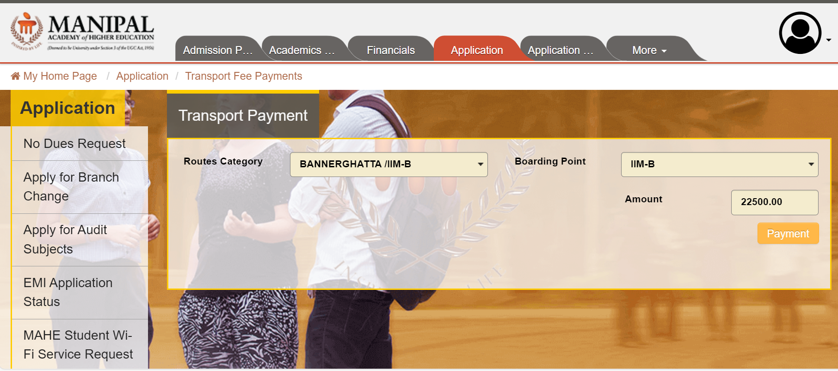
Step 5: Select payment click on agree button and submit.

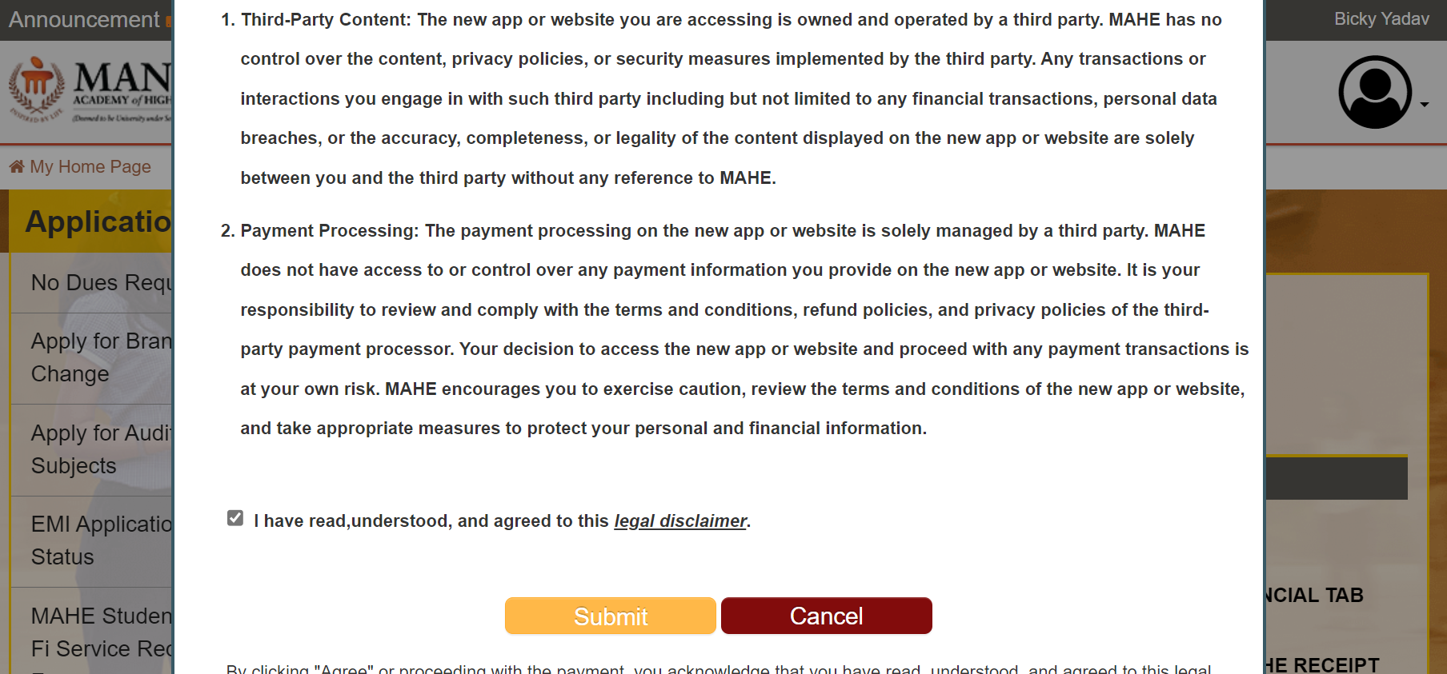
Step 6: Click on payment option and proceed to pay.
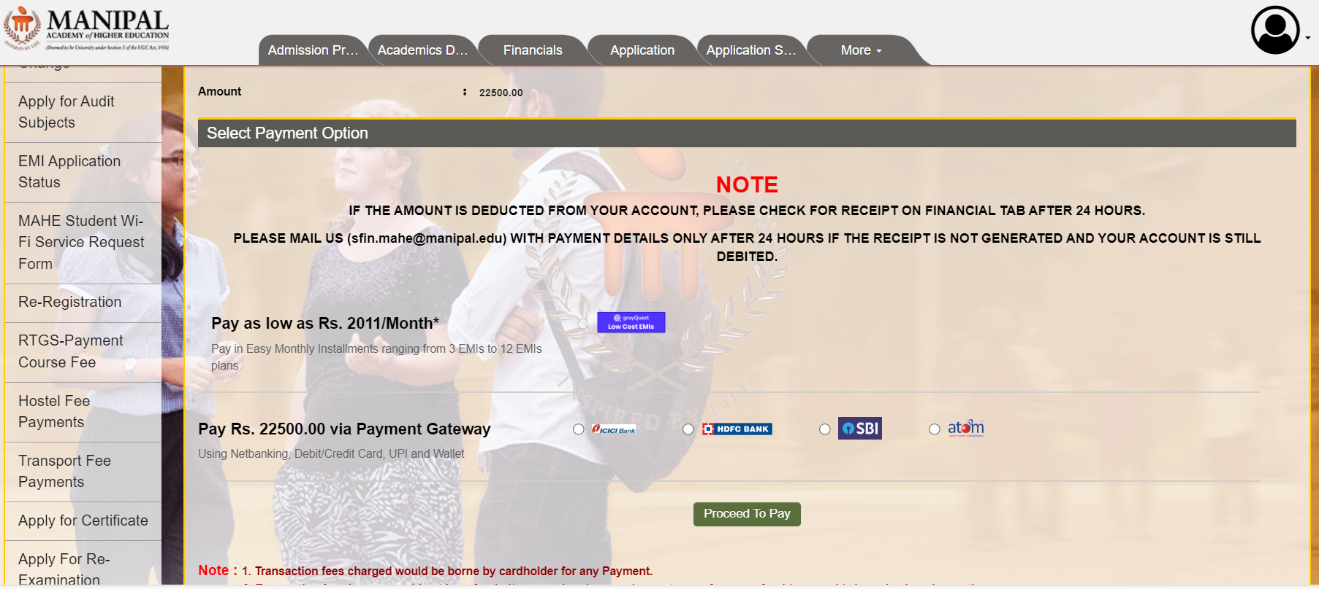
Step 7: Once payment is successful, please take screenshot and share the same to transport.maheblr@manipal.edu email address.

